Design

Document

iBidPharma

Index

|  |  |  |
| --- | --- | --- |
| Sr No | Content | Page No |
| 1 | Introduction | 3 |
| 2 | Architectural Design | 3 |
| 3 | High Level Design | 6 |
|  | 3.1 E-R Diagram | 6 |
|  | 3.2 Page Navigation Diagram | 7 |
|  | 3.3 Data Flow Diagram | 9 |
|  | 3.4 Deployment Diagram | 12 |
| 4 | Low Level Design | 13 |
|  | 4.1 Database Design | 13 |
|  | 4.2 Stored Procedure | 16 |
|  | 4.3 Details Of Page Navigation | 17 |

1. **Introduction**

This document is meant for the description of the structure and the database which we are using in this project. This document gives brief description about Architecture of the system, E-R diagram of the system and the table descriptions, the page navigation diagrams and the detail description for the page navigation.

1. **Architecture Design**

Following diagram shows the details of the iBidPharma system architecture.

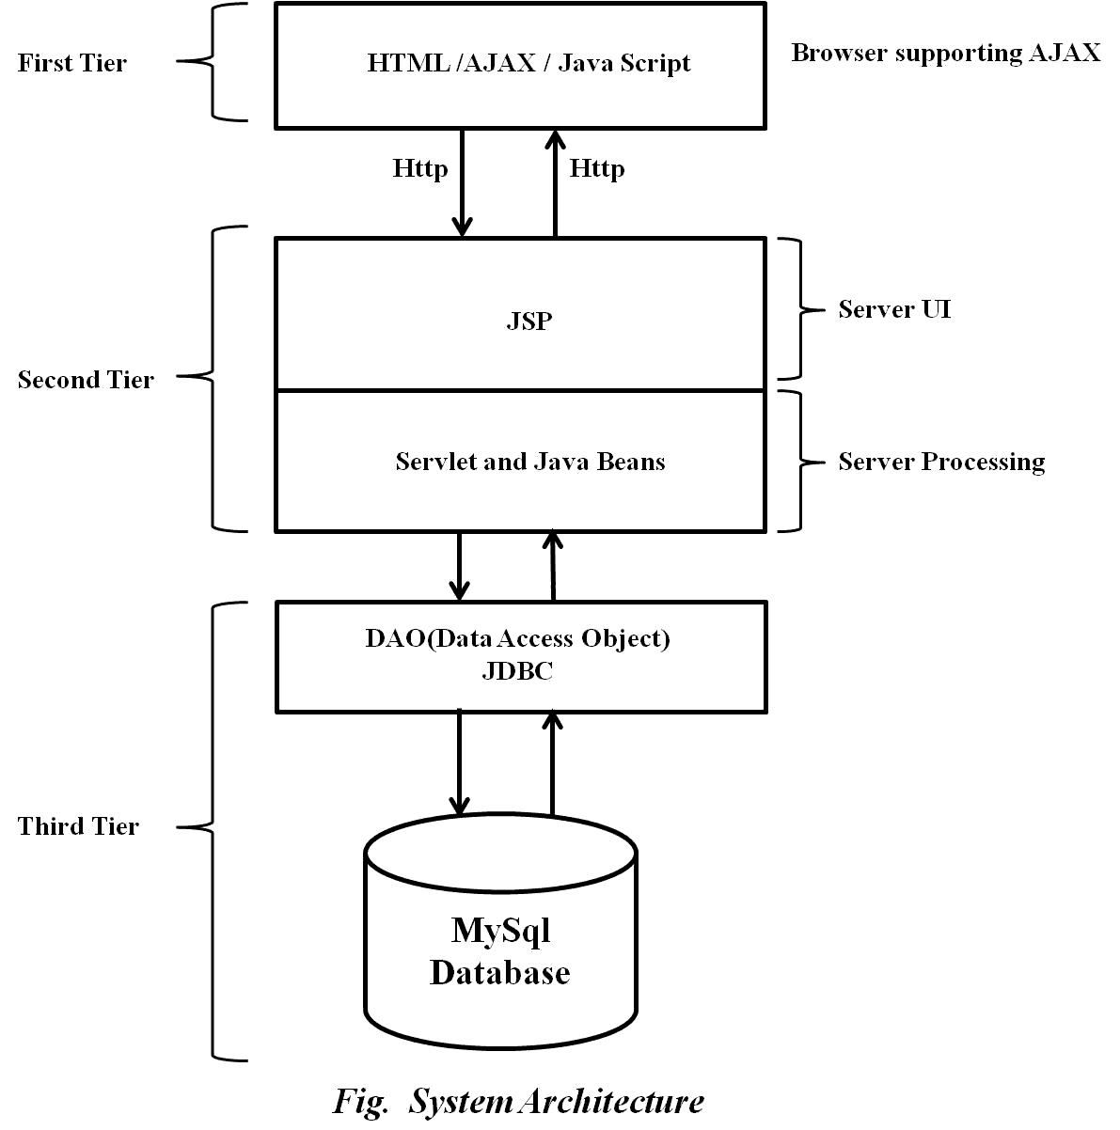

This System consist of three tiers as listed below,

* First tier
* Second tier
* Third tier
* **First Tier**

This tier is used for user interface and it is called as client tier. In this tier we are using AJAX because of it provides better interactivity, easier navigation, compact. The use of java script facilities us for the client side validation. That’s why in first tier we are using the java script. We are using HTML for the presentation purpose.

* **Second Tier**

Second Tier is comprises of two parts listed below.

1. **Server UI**

In this part of second tier we are using JSP, because it provides better UI to system, as well as it provides the dynamically designing of pages.

1. **Server Process**

Servlet API is standard and freely available on the internet (like JSPs) servlets have the advantages like ease of development & platform independence (like Java) they can access all the J2SE and J2EE APIs can take the full advantage & capabilities of the Java programming language.

* **Third Tier**

Third tier consist of a Data Access Object (DAO) and the back end i.e. the database of iBidPharma system.

1. **Data Access Object (DAO)**

Data access object layer has proven good in separate business logic layer and persistent layer. The DAO design pattern completely hides the data access implementation from its clients.

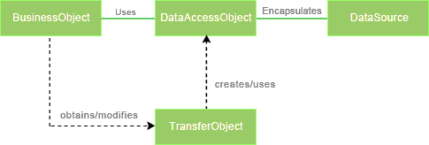

*Fig Data Access Object (DAO) Mechanism*

1. **Java Database Connectivity (JDBC)**

JDBC is used to provide database connectivity from java to database. Using Java database connectivity we can update/retrieve data to/from database with java programs. The main advantage of using JDBC is we can execute database queries by the program so that we can utilize the functionality provided by the database (with the queries). More over we can use triggers too. JDBC provides much other functionality (like the functions provided by CallableStatemtent class) to manage the data. Additionally, loading the driver will be different to different databases.

1. **High Level Design**

**3.1 ER-Diagram**

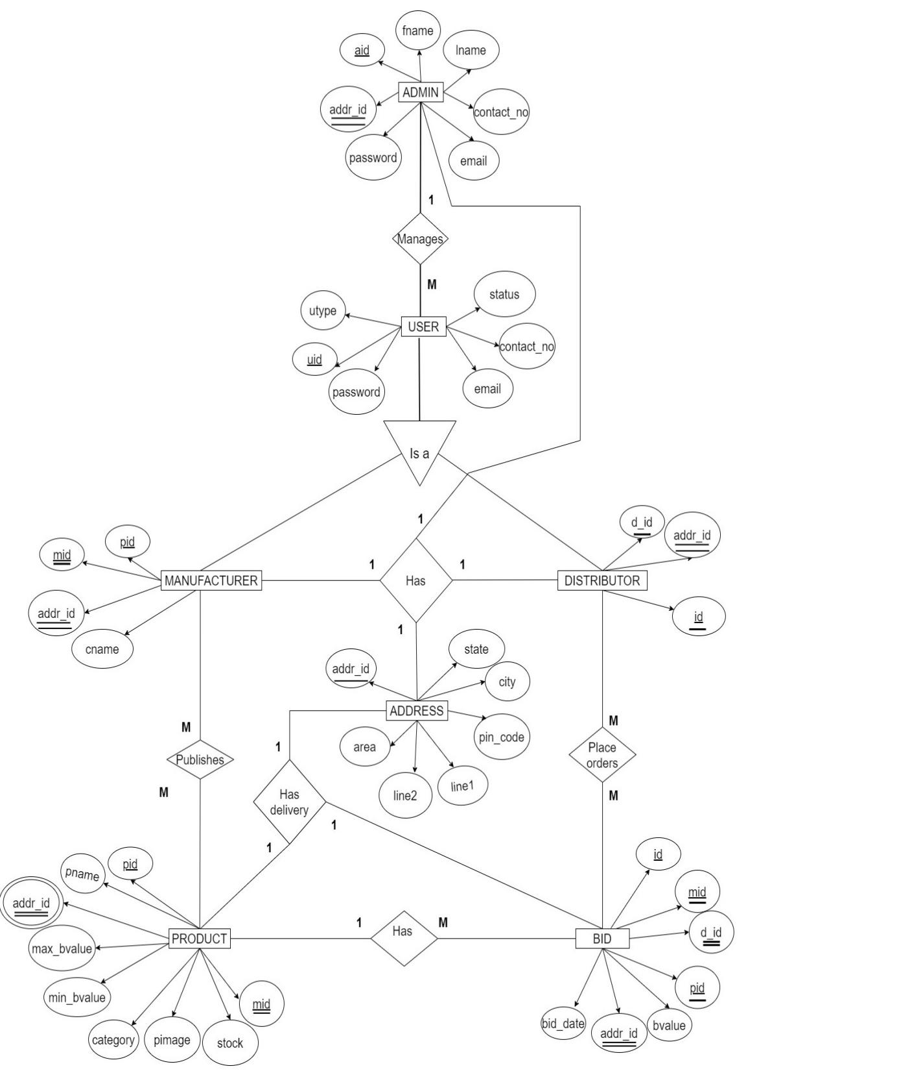

Above E-R Diagram shows that database of e-Farming system consist of following entities:

* **User**

This entity contains the Uid, CompanyName, Email, Password, ContactNo, Address, Type attributes.

* **Product**

This entity contains the Pid, PName, Category, Bid Price, Stock, Image, Location, Uid attributes

* **Admin**

This entity contains the Aid, Fname, Lname, Email, Password, ContactNo, Address attributes.

* **Bid**

This entity contains the Id, Date, Uid, Pid attributes.

**3.2 Page Navigation Diagram**

* Manufacturer

Following diagram explains the page navigation for the Manufacturer module.

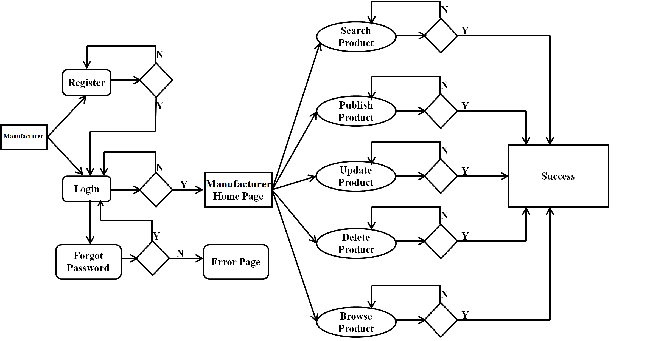

* Distributor

Following diagram explains the page navigation for the Distributor module.

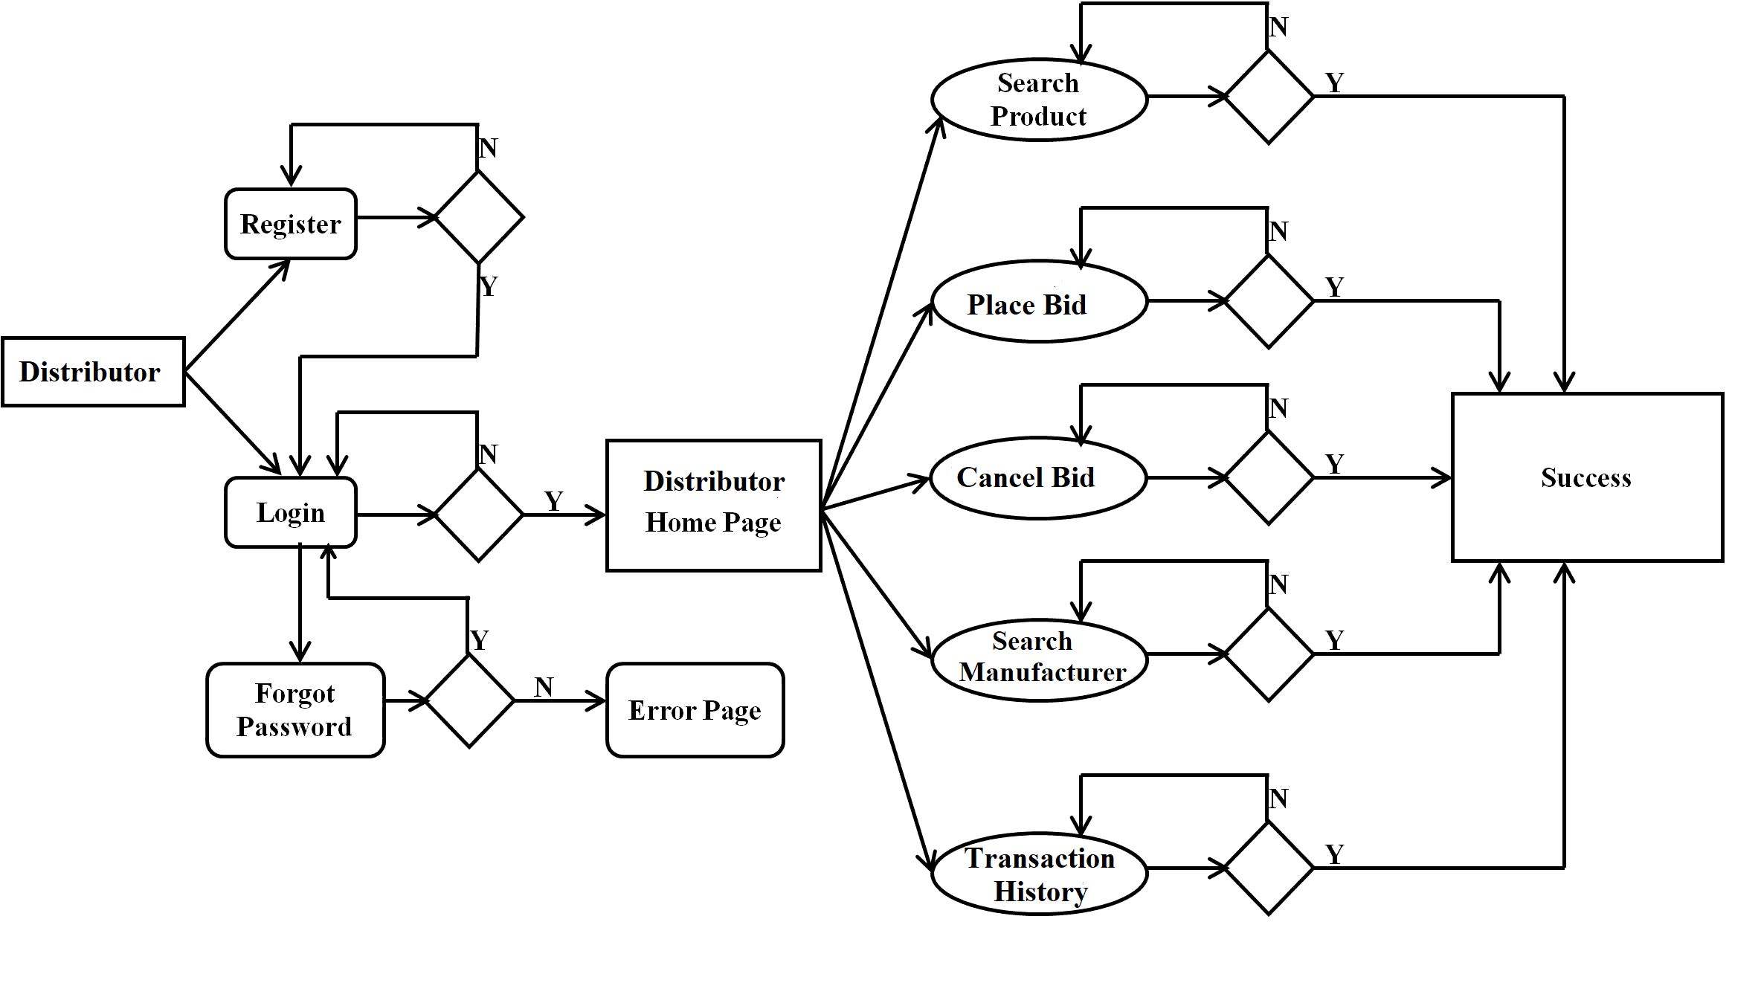

* Admin

Following diagram explains the page navigation for the Admin module.

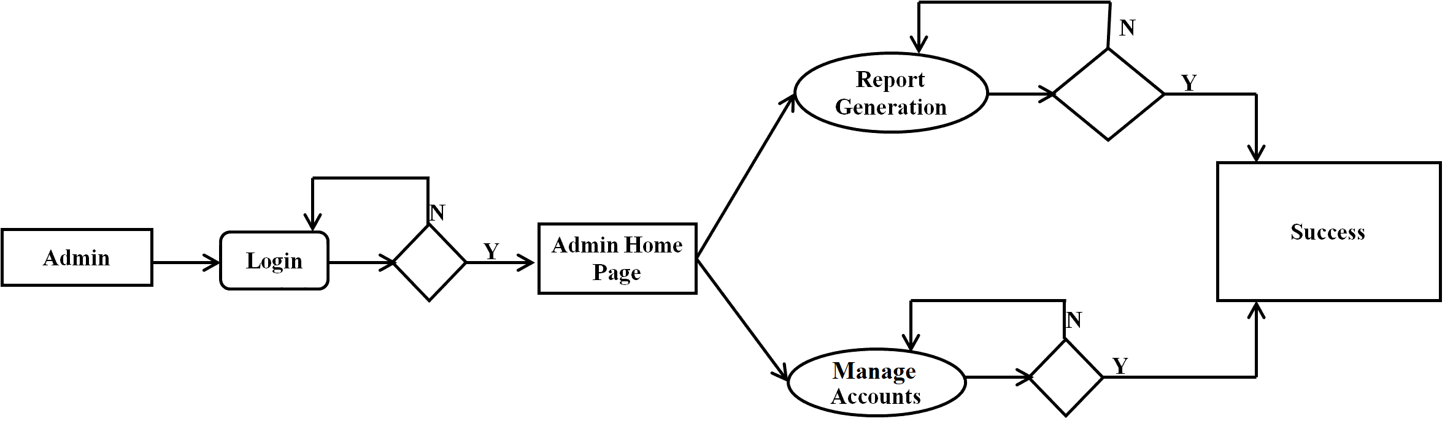

**3.3 Data Flow Diagram**

* 0-Level DFD

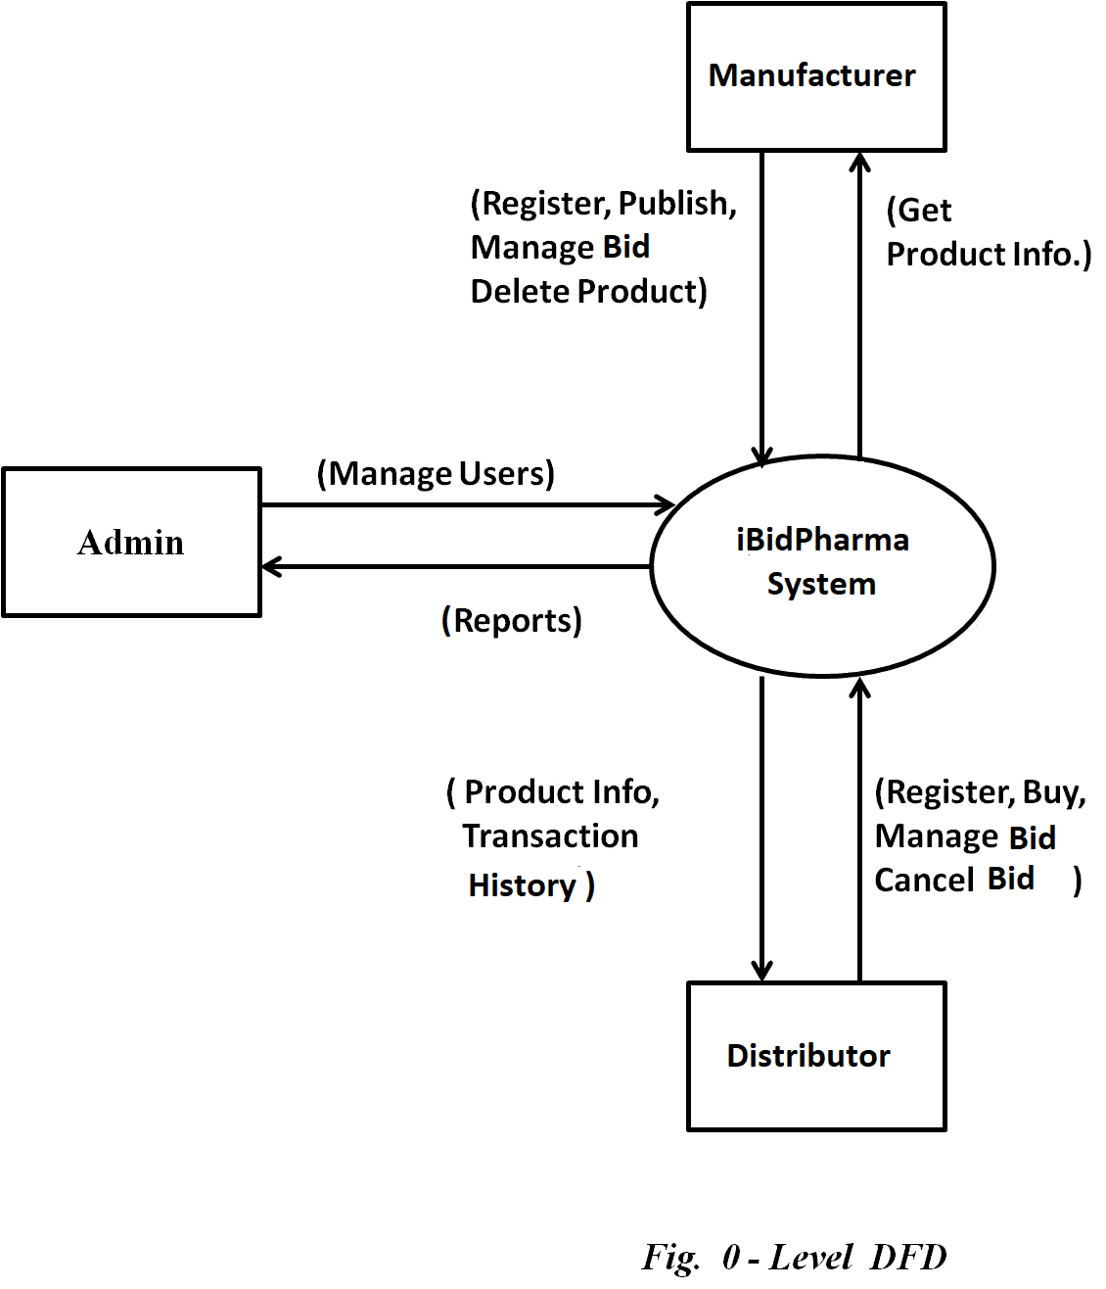

In 0-Level DFD, there are three Entities:

1. Manufacturer
2. Distributor
3. Admin

* 1-Level DFD

**(Pending…)**

In 1-Level DFD, Manufacturer Entity having following processes:

* Register(Process 1.0)
* Login(Process 2.0)
* Forgot Password(Process 3.0)
* Change Password(Process 4.0)
* Update Account(Process 5.0)
* Publish Product(Process 6.0)
* Update Product(Process 7.0)
* Delete Product(Process 8.0)
* Choose Best Bid(Process 9.0)
* Search Distributor(Process 10.0)
* View Order History(Process 16.0)
* Report Generation(Process 20.0)

Distributor Entity having following processes:

* Register(Process 1.0)
* Login(Process 2.0)
* Forgot Password(Process 3.0)
* Change Password(Process 4.0)
* Update Account(Process 5.0)
* Search Product(Process 11.0)
* Place Bid(Process 12.0)
* Cancel Bid(Process 13.0)
* Browse Bids(Process 14.0)
* Search Manufacturer(Process 15.0)
* View Transaction History(Process 17.0)
* Report Generation(Process 20.0)

Admin Entity having following processes:

* Login(Process 2.0)
* Change Password(Process 4.0)
* Update Account(Process 5.0)
* Account Management(Process 18.0)
* Revenue Management(Process 19.0)
* Report Generation(Process 20.0)

1. **Low Level Design**

**4.1 Database Design**

1. Tbl_User

|  |  |  |  |  |  |
| --- | --- | --- | --- | --- | --- |
| **Field** | **Type** | **Null** | **Key** | **Default** | **Description** |
| Uid | Integer | No | Primary key | Null | User ID |
| CompanyName | Varchar(45) | No |  | Null | Name of Company |
| Email | Varchar(45) | No |  | Null | User’s Email ID |
| Password | Varchar(15) | No |  | Null | Account Password |
| ContactNo | Integer | No |  | Null | User’s Contact No. |
| Address | Varchar(100) | No |  | Null | Company Address |
| Type | Varchar(15) | No |  | Null | Manufacturer / Distributor |
| Status | Integer | No |  | Null | Enabled / Disabled |

1. Tbl_Admin

|  |  |  |  |  |  |
| --- | --- | --- | --- | --- | --- |
| **Field** | **Type** | **Null** | **Key** | **Default** | **Description** |
| Aid | Integer | No | Primary key | Null | Admin ID |
| Fname | Varchar(45) | No |  | Null | First Name |
| Lname | Varchar(45) | No |  | Null | Last Name |
| Email | Varchar(45) | No |  | Null | Admin’ Email ID |
| Password | Varchar(15) | No |  | Null | Account Password |
| ContactNo | Integer | No |  | Null | Admin’s Contact No. |
| Address | Varchar(100) | No |  | Null | Permanent Address |

1. Tbl_Product

|  |  |  |  |  |  |
| --- | --- | --- | --- | --- | --- |
| **Field** | **Type** | **Null** | **Key** | **Default** | **Description** |
| Pid | Integer | No | Primary key | Null | Product ID |
| PName | Varchar(45) | No |  | Null | Product Name |
| Category | Varchar(45) | No |  | Null | Product Category |
| Bid Price | Double | No |  | Null | Product Price |
| Stock | Double | No |  | Null | Product Quantity |
| Location | Varchar(100) | No |  | Null | Deliverable Locations |
| Image | Varchar(45) | No |  | Null | Product Image |
| Uid | Integer | No | Foreign key | Null | Reference to Uid (Tbl_User) |

1. Tbl_Bid

|  |  |  |  |  |  |
| --- | --- | --- | --- | --- | --- |
| **Field** | **Type** | **Null** | **Key** | **Default** | **Description** |
| Id | Integer | No | Primary key | Null | Bid ID |
| Uid | Integer | No | Foreign key | Null | Reference to Uid (Tbl_User) |
| Pid | Integer | No | Foreign key | Null | Reference to Uid (Tbl_Product) |
| Date | Date | No |  | Null | Bidding Date |